DrugGuard: ML based Drug-Drug Interaction Prediction

Abstract
Drug-drug interactions (DDIs) are a major cause of adverse drug events and pose significant risks to patient safety, yet exhaustive experimental validation of all possible drug combinations is infeasible due to the exponential growth in approved pharmaceutical compounds. This paper presents DrugGuard, a machine learning based system for predicting potential DDIs using only molecular structure information, eliminating the need for pharmacological or biological data such as protein targets or metabolic pathways. The proposed approach constructs an end to end pipeline that parses raw DrugBank XML data to extract 2.9 million known interaction pairs, integrates molecular structures from SDF files to obtain 2.36 million valid SMILES based pairs and converts each molecule into numerical representations using 2048 bit Morgan fingerprints. Drug pairs are represented as concatenated 4096 bit feature vectors and used to train an XGBoost classifier on a balanced dataset of 100,000 samples comprising both interacting and randomly generated non interacting pairs.
This paper presents DrugGuard, which is a system we built to predict potential DDIs using only molecular structure data. So, no need of protein targets or pathway information, or any of the other factors that generally make the data collection a herculean task. Our pipeline extracts roughly 2.9 million known interaction pairs from DrugBank's XML data, then cross references these with SMILES strings from SDF files to get around 2.36 million usable pairs. Each molecule is encoded as a 2048-bit Morgan fingerprint and drug pairs are represented as 4096-bit concatenated vectors which are then fed into an XGBoost classifier which is trained on a balanced set of 100,000 samples. We tested three fingerprint radii (r = 1, 2 and 3) and r = 3 came out on top with 71% accuracy and a ROC-AUC of 0.78. The system outputs binary predictions along with confidence scores and severity labels (Low, Moderate or High). The system utilizes DrugBank's database as a primary source for human readable descriptions; if no match is found, it then uses a Language Model (LLM). Unlike most applications, all of the hardware used in building the system will be off-the-shelf, with no need for additional GPUs or heavy systems.
Keywords Drug-Drug Interactions, Machine Learning, XGBoost, Morgan Fingerprints, SMILES, DrugBank, Interaction Prediction

1. Introduction

Clinicians have long faced the problem of DDI (Drug-Drug Interaction) being one of the hardest issues in clinical medicine. The potential for two drugs used together produces altogether new and different results from when only a single agent is given, and typically the result is not positive. The number of drugs being approved for clinical use is increasing at an incredibly rapid pace, the number of possible drug combinations (the result of taking two drugs together) is going to be too extensive to ever investigate all of them in the laboratory [1][2].

A more significant problem associated with this issue is that the majority of present-day methods for predicting drug-drug interactions (DDIs) are based on pharmacological and biological data including, but not limited to, drug targets, enzyme activity, and known side effects [3]. While these methods have been effective in the past, they will not work on new or less studied drugs as this information is usually lacking or incomplete, therefore limiting their use.

A promising alternative is to develop molecular structure-based systems for predicting DDIs. In theory, the use of a SMILES (Simplified Molecular Input Line Entry System) string to identify and analyze the molecular structure of any drug should make it possible to effectively generalize the chemical data across a wider range of drugs, thereby allowing for more accurate and comprehensive prediction of DDIs [4][5]. The real challenge is to develop a methodology that works in practice at a large scale with “dirty” (i.e., real-world) data, and produces utility for its intended purpose from the generated outputs.

Herein, we present DrugGuard. DrugGuard is a machine learning based framework used to predict drug-drug interactions based solely on the molecular structure of the drugs being studied. DrugGuard is an end to end pipeline that utilizes DrugBank data, extracts interaction pairs from that data, generates molecular representations of each interaction pair via Asmorgan fingerprints, and trains an XGBoost classifier for the purpose of predicting drug-drug interactions. In addition to being able to predict drug-drug interactions, DrugGuard incorporates a hybrid explanation approach by combining verified interaction descriptions from trusted sources with LLM generated (language model) explanations; thereby increasing the interpretability of the predicted drug-drug interactions to end users.
The remainder of this paper is organized as follows: Section 2 describes existing research on predicting drug-drug interactions; Section 3 provides a description of DrugGuard's system architecture; Section 4 outlines the feature engineering and machine learning processes that will occur within DrugGuard; Section 5 discusses the limitations of this approach and presents recommendations for future research; Section 6 describes how the various components of DrugGuard will be evaluated via experiments, including preparation of datasets and measuring model performance; Section 7 describes and analyzes these experiments, and compares DrugGuard's performance to previous works in predicting drug-drug interactions; Section 8 describes the implementation of DrugGuard via examples of its outputs; Section 9 provides validation of the predictions produced by DrugGuard by comparing them to existing pharmacological knowledge sources and conclusion.
2. Related Work
2.1 Drug-Drug Interaction Prediction Approaches
Statistical methods were the main types of predicting DDI at the start. They relied on drug similarity metrics and manual features created according to the known properties of compounds. As machine learning became more developed, various machine learning algorithms entered into this area of the DDI prediction space: logistic regression, SVMs, and random forests typically did better than previous rule-based systems. XGBoost has repeatedly outperformed other algorithms using structured biomedical data, primarily because it is very good at working with high-dimensional heterogeneous feature sets [6] [7]. A common challenge across the majority of these methods is that they rely on multisource pharmacological datasets, which are not always obtainable, particularly for newly approved/less studied compounds.
2.2 Structure Based and Deep Learning Methods
There are two kinds of approaches based on structure. The first is by taking the molecular representation and converting it into some form of numerical representation without requiring any actual data. Morgan fingerprints are used more often than other encoding methods because they convert a molecular structure into a fixed-length binary vector (molecular fingerprint) that can be used directly in multiple machine learning pipelines [8] [9]. Secondly, various deep neural networks such as graph neural networks or attention based architectures provide higher accuracy compared to other methods because they model molecular topology to some extent [8][9]. The downside is the amount of time and resources needed to use these models, which include having a GPU infrastructure in place, the time required to train the networks, and then the difficulty in providing a way for these models to work in resource-limited environments.
2.3 Data Sources and Large-Scale DDI Modeling
DrugBank represents the most widely distributed and accepted source of interaction data for DDI studies; it offers curated interaction data to be used with molecular structure data for many compounds [10]. One caution I would like to present is that many published studies use pre-processed versions of DrugBank and not the original source files. As a result, pre-processing errors are difficult to trace back to the original source file(s), which affects reproducibility [11]. However, developing systems based upon the raw XML and SDF files enables transparency and control, but also presents significant engineering hurdles, such as having to manage memory usage while parsing, structural inconsistencies across the various files, and having to implement some mechanism for reconciling the two databases.
2.4 Interpretability and Deployability in DDI Systems
In the area of healthcare, interpretability is necessary because clinicians and end users need to understand why a model makes its predictions. Compared to deep learning models, which are often viewed as "black boxes", traditional machine learning methods such as decision trees and gradient boosted trees have some degree of interpretability [12]. Some recent work has attempted to develop systems that combine prediction models with some type of explanation layer, such as rule based systems and natural language generation techniques, to create more user friendly systems [13]. Additionally, to deploy DDI prediction models in practice, DDI prediction models must be lightweight and produce fast inferences without requiring any special hardware, which is a challenge for most deep learning approaches [14].
Based on the above discussion, it is evident that existing DDI prediction approaches face trade- offs between accuracy, interpretability and deployability. Methods relying on multisource pharmacological data suffer from limited availability and integration complexity, while deep learning based approaches, although highly accurate, are computationally expensive and difficult to deploy in real time settings. In this context, the proposed DrugGuard framework adopts a structure only prediction approach combined with a lightweight machine learning model and a hybrid explanation mechanism, enabling accurate, interpretable and scalable DDI prediction. A comparative analysis of these approaches is presented in Table 1.
System / Approach | Model Used | Features Used | Limitations | Advantage of DrugGuard
Traditional Statistical Models | Logistic Regression, Similarity-based methods | Drug similarity, clinical data | Limited predictive power; relies on handcrafted features | Automated feature extraction via Morgan fingerprints
Machine Learning Models | SVM, Random Forest, Gradient Boosting | Pharmacological data (targets, enzymes, pathways) | Requires multi-source biological data; not always available | Only molecular structure required (universally available)
Structure-Based ML (Literature) | XGBoost, Random Forest | Chemical fingerprints (fixed radius) | Limited experimentation on fingerprint parameters | Systematic evaluation across radii r=1, 2, 3
Deep Learning Models | GNNs, Siamese Networks, Attention-based | Molecular graphs, drug-protein networks | High compute cost; GPU required; difficult to deploy | Lightweight, CPU only, fast inference
Research Frameworks (e.g. ChemicalX) | Multiple deep learning architectures | Multi-modal biomedical data | Complex setup; no direct deployment path | End-to-end pipeline with real-world usability
DrugGuard (Proposed) | XGBoost | Morgan Fingerprints (r=3, 2048-bit) | Slightly lower accuracy than deep learning models | Structure-only, fast, deployable, interpretable, scalable
Table 1: Comparison of Different Approaches
3. System Architecture
3.1 Overview
DrugGuard follows a layered system architecture designed to enable efficient data processing, scalable machine learning and real time prediction of drug-drug interactions. The structure of the system is represented in Fig. 1, which depicts the high-level view of the data flow and interactions between the components of the system. The workflow within the system consists of transforming the raw data associated with the different drugs into predictions usable by the end user by utilizing a series of defined stages. The work component produces output that will be consumed by the next work component to perform the next step in the overall system, enabling the system to have defined functions and modularised data flow between each component; these functions and data flows between the components will ensure the modular design and maintainable architecture of the overall system.
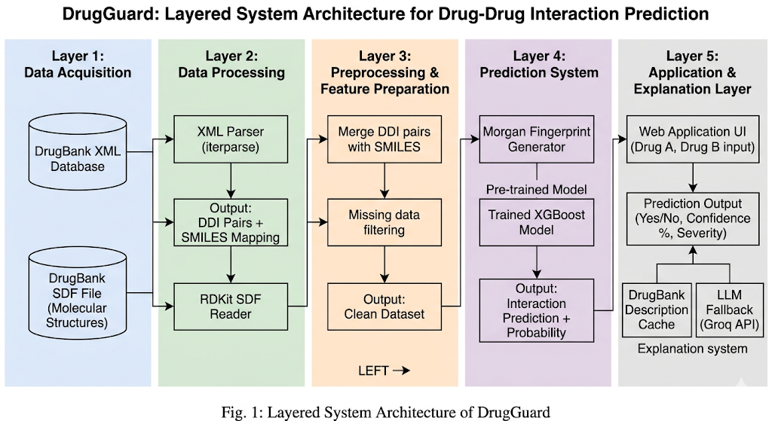
3.2 System Architecture Diagram
Fig. 1: System Architecture Diagram

3.3 Layer 1: Data Acquisition
The purpose of layer 1 is to obtain the raw data that is necessary to predict drug interactions. DrugGuard relies upon two main databases: DrugBank's XML and DrugBank's SDF (Structure Data File) databases. The DrugBank XML database includes drug interaction data, which specifies the types of drugs involved in each interaction as well as other descriptive data for those drugs; the SDF database contains the molecular structures of the drugs. These two sources will ultimately serve as the foundation of the DrugGuard system, and therefore will need to be processed separately in layer 2.
3.4 Layer 2: Data Processing
This layer converts the drug interaction data as defined in the DrugBank XML database into a structured way for use in future analyses. The DrugBank XML database is processed using a streaming XML parser (specifically, an iterparse) that enables extraction of all the drug interactions without loading the entire XML file into memory; the DrugBank SDF file, on the other hand, is processed using the RDKit software package to build a link between DrugBank IDs and their corresponding SMILES representation. The results from both processes will then be combined to create an integrated data set containing drug interaction data along with the corresponding molecular structures for each drug.
3.4 Layer 3: Preprocessing (Data Cleanup) and Feature Preparation.
The activities of Layer 3 are focused on cleaning and organizing the data set in order to allow the data set to become an appropriate input for machine learning. The drug pair interaction data set produced as a part of Layer 2 can now be merged with its corresponding SMILES representation of the drug molecule, thereby producing a full, cleaned, and completely organized data set that allows drug pairs to be examined as an input into the prediction system. In addition to cleaning and organizing the drug pair and SMILES representation, data entries that were produced in Layer 2, that do not contain structural information or are invalid in terms of structure, will be filtered out so that only valid pairs of drug molecules will remain. The outcome of Layer 3 is a cleaned data set containing valid drug pairs and SMILES representation, which can serve as the input to the prediction system.
3.5 Layer 4: Prediction Model.
The prediction model is the main computational element of DrugGuard. In Layer 4, the molecular structure of the drugs will be converted to its feature vector (numerical representation) using the creation of the Morgan Fingerprint (which provides a representation of the various structural characteristics possessed by the drug molecule). The feature vector will then be passed to a pre-trained XGBoost model for prediction of whether the drug pairs will produce an interaction. The prediction XGBoost model will provide two types of data: (1) a binary classification indicating whether the drug pair will or will not produce an interaction and (2) a probability of the classification indicating the likelihood that the drug pair will or will not interact.
3.7 Layer 5: Application and Explanation Layer
The last layer of the architecture is where users interact with the model's outputs, thereby increasing interpretability of the model's predictions. Users will type in the names of two drugs into a web-based interface, activating the prediction pipeline as soon as they do so. The results of these predictions will be presented to users using an easily interpretable format that describes whether or not an interaction occurred, gives a confidence level (as a percentage) and lists the severity level of the interaction (where applicable). In order to improve the interpretability of the predicted interactions, there are two ways that the explanatory component of the system works. First, if a valid description of an interaction exists in the DrugBank database (which was pre-built by entering in all of the interactions) the system will retrieve that description as the explanation for the two drugs’ suspected interaction. If there is no valid interaction description in the DrugBank database, the system will request the explanation from an external source using an LLM via an API. This hybrid explanatory methodology enables the system to explain predicted interactions with both high fidelity and broad coverage.
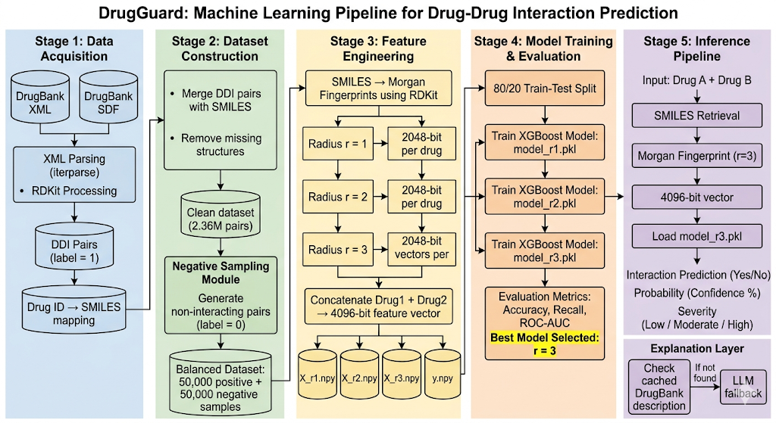
4. Machine Learning Pipeline
Fig. 2: Machine Learning Pipeline
4.1 Data Acquistion
Data for DrugGuard is acquired initially through DrugBank in XML and SDF format. A file is created using iterparse and stored for processing, and both XML and SDF are imported into RDKit for processing purposes. Drug IDs are extracted from the DDIs recorded in the XML, and a mapping of Drug IDs to SMILES creates a labelled set of interacting pairs for use in later phases of the DrugGuard system.
4.2 Dataset Construction
The labelled DDI data is combined with the corresponding SMILES record to create a clean set of 2.36 million records by deleting any records missing molecular representation. The original dataset primarily contained evidence from known DDI records. Hence, to establish a representative dataset, a random sampling of drug combinations not represented within Drug Bank's DDI records are produced via a Negative Sampling Module, producing a total of 100,000 records for use in training and validating the system containing 50,000 interaction and 50,000 non-interaction records.
4.3 Feature Engineering
Molecular structures cannot be used as data input into machine learning algorithms therefore, the only way to use these data types with machine learning is to create Morgan fingerprints for each drug by calculating a set of 2048 bits (binary) and a 2048-bit integer for each pair of drugs and concatenating them together to form a set of four digits as follows:
Fpair​ = Fdrug1​∣∣Fdrug2​
Molecules can be characterized by how they relate to one another in terms of their structure in order to understand the impact of their environment by analysing their degree of similarity at three distances (radius):
- r = 1: Establishes the immediate mountain structure
- r = 2: Establishes the intermediate topology within the two mountains
- r = 3: Establishes the overall topography of the two mountains
These similarities will thus yield three sets of features (X_r1, X_r2 and X_r3) and one set of labels (Y). The three feature sets and the label set will be stored in NumPy files for ease of analysis. (file names: X_r1.npy, X_r2.npy, X_r3.npy, y.npy)
4.4 Model Training
Training and evaluation datasets are divided into two subsets, each with an 80%/20% split. For each of the three feature groupings, an XGBoost classifier will be trained separately, resulting in three separate model files (model_r1.pkl, model_r2.pkl, model_r3.pkl). XGBoost is a gradient boosting ensemble method that builds a large number of decision trees. It is well suited for high dimensional binary feature vectors, as is the case with these feature groups.
To train the model, binary cross-entropy (Log Loss) is used as the objective function. The XGBoost algorithm has multiple hyperparameters. For this project, the main hyper-parameters to be tuned include:
- Number of trees = 100
- Maximum depth = 6
- Learning rate = 0.1
4.5 Inference Pipeline
When using the drug name-based inference method, users enter the two drug names (Drug A and Drug B) into the system, which obtains the corresponding SMILES strings. The system realizes Morgan fingerprints using RDKit at radius = 3 and builds a single 4096-bit feature vector from both cards; the feature vector is sent to model_r3.pkl, which returns:
- Interaction Prediction: Yes / No
- Confidence Score: y^​×100%
- Severity Classification: Low / Moderate / High
- Explanation Layer: All predictions regardless of DrugBank database coverage will include a human-readable rationale to explain what the model predicted based on its inputs.
4.5 Evaluation Metrics
Metrics for Evaluation Evaluation metrics are based on standard classification metrics for the three trained models. ROC-AUC - This metric measures how well the model is able to distinguish between interacting and non-interacting pairs at all classification thresholds. A value of 0.5 indicates random classification while a value of 1.0 indicates perfect classification.
- Accuracy: TP+TNTP+TN+FP+FN/{TP + TN}{TP + TN + FP + FN}TP+TN+FP+FNTP+TN​
- Recall: TPTP+FN/{TP}{TP + FN}TP+FNTP​
- ROC-AUC: Measures the model's ability to distinguish between interacting and non-interacting pairs across all classification thresholds. A score of 0.5 indicates random performance; 1.0 represents perfect classification.

5. Limitations and Future Work
5.1 Limitations
One of DrugGuard's main limitations is that it only considers molecular structure, while in real clinical situations, pharmacokinetic factors such as enzyme inhibition or competition for metabolism often drive drug interactions. Therefore, using only structure to measure interactions will likely not capture all of the other factors that affect drug/drug interactions, although the model should do reasonably well in predicting those types of structurally driven interactions. [15] Therefore, it's likely that the model will tend to miss many of the types of pharmacokinetically based drug/drug interactions that would be captured by a more complete and feature-rich way of developing a prediction model.
It should also be disclosed that for negative sample selection, we randomly selected unreported pairs of drugs as being non-interacting, which is a standard practice in all DDI studies; however, some of these unreported pairs could simply be unreported and NOT truly non-interacting, thus creating some added label noise in our training set. Since there will not likely be a true negative device, this will be unavoidable.
Even with these issues DrugGuard does perform competitively with a minimal set of features, and this is adding to the body of knowledge regarding how much structure alone can provide information regarding drug interactions.
5.2 Future Work
DrugGuard has many further possibilities for enhancement of its capability and usefulness. One area of exploration would involve adding additional types of pharmacological data (e.g., drug targets, enzymes, and pathways) to the existing structural data to enhance the prediction accuracy at this point. Another potential area is the use of advanced deep learning methods (e.g., graph neural networks) to directly model molecular structures as graphs, which provides the opportunity to learn more complex relationships [16].
Overall, these enhancements would greatly improve predictive power and reliability of DrugGuard in the real world while maintaining its major advantage of structural generalizability.
6. Experimental Evaluation
6.1 Dataset and Experimental Setup
The experiments carried out in this work utilized data obtained through pharmacological [17] information from Drug Bank, which contains complete data (with respect to available) for known drug-drug interactions as well as molecular structure data for each of the two interacting drugs. Following the data preprocessing and filtering, a dataset of approximately 2.36 million drug-drug interaction pairs (interacting pairs) was established.
To generate negative samples (i.e. drugs that are not interacting), we randomly selected drug pairs in the absence of pairs from the Drug Bank data. The balanced set used to train the machine learning models contained 50,000 positive drug pair samples and 50,000 negative drug pair samples.
The whole Drug Drug interaction dataset was split 80% train dataset and 20% test dataset. All experiments used Python-based packages to generate features using RDKit and to train the machine learning models via XGboost libraries.

6.2 Model Performance
The performance of the DrugGuard model was evaluated using standard classification metrics, including accuracy, recall, and ROC-AUC. Three models were trained using Morgan fingerprints with radii r=1,2,3, and their performance was compared.
Radius | Accuracy | Recall | ROC-AUC
r = 1 | 68% | 0.70 | 0.753
r = 2 | 70% | 0.73 | 0.768
r = 3 | 71% | 0.73 | 0.780

The results show a consistent improvement in performance with increasing fingerprint radius. The model with r=3 achieves the highest accuracy and ROC-AUC, indicating that incorporating a wider molecular neighborhood enhances the model’s ability to capture interaction-relevant structural patterns.
6.3 Discussion of Results
The DrugGuard model has been assessed according to standard classification performance metrics, specifically accuracy, recall and ROC-AUC). Models based on Morgan fingerprints have been trained with radii of r=1, r=2 and r=3, and compared against each other for accuracy.
As described in Section 4.6, the results indicate a steady increase in predictive capability as the radius of molecular neighbourhood represented by the fingerprint increases. The model trained using fingerprints with r=3 produces the best results for both accuracy and ROC-AUC; therefore it appears that expanding the width of the molecular surroundings allows for more accurate modelling of structural patterns relevant to interactions.
7. Results and Discussion
7.1 Discussion of Results
According to the experimental data, DrugGuard can accurately predict drug-drug interaction with only the use of drug molecular structures. The ROC-AUC value of DrugGuard was 0.78, which indicates a very strong capability to distinguish which compounds will interact with each other v/s those that will not interact or an indication of the ease of use of DrugGuard to find compound pairs that will interact v/s ones that will not interact.
As discussed in Section 6 increasing the radius of the fingerprint when searching DrugGuard for interacting v/s non-interacting drug pairs demonstrates improved performance. Increasing the radius of the fingerprint allows for searching over a larger molecular neighborhood, which results in a greater number of potentially relevant interaction patterns. These data indicate the importance of structural context as it relates to the pharmacology of individual compounds.
7.2 Comparison with Existing Approaches
As indicated in Section 2, the majority of DDI prediction systems utilize additional pharmacological data, such as: protein targets, metabolic pathways and side effect profiles, to facilitate predictions on DDI potential. Although these systems generally have much higher predictive accuracy and can therefore be more accurate in helping to determine potential DDI’s; since they require the integration of large and diverse amounts of data, they cannot be used for all potential DDI’s.
Because DrugGuard only relies on molecular structure (i.e., fingerprints) as an input for predicting DDI, it is much easier to develop and implement when compared with other available systems. Despite the more limited input provided to the DrugGuard system, its performance is at least as good as that of other available DDI prediction systems. Furthermore, these data indicate that the molecular structure alone provides sufficient information to make a meaningful prediction.
7.3 Practical Implications
The research findings indicate that the DrugGuard tool can be used as a reliable means of recognizing possible drug-drug interactions (DDIs) within both clinical and pharmacist settings. Its structure-only method provides it the ability to operate even when biological and pharmaceutical data is not available.
Additionally, the DrugGuard system's lightweight structure allows for real-time prediction making it ideal for integration into web-based decision support systems. An explanation layer is included to improve usability and provide interpretable results, which is critical in healthcare applications.
8. System Implementation and Outputs
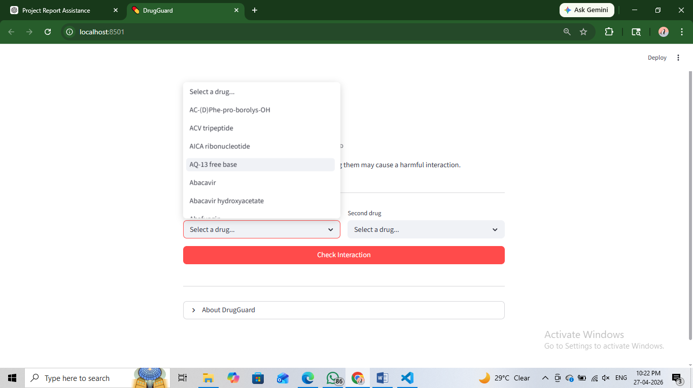
This section contains selected output images of DrugGuard’s practical application. The output images demonstrate the ability of the web application to generate interaction predictions and give the user the ability to interact with the web application by selecting drugs and obtaining an explanation for the output.

Fig. 3: Drug selection interface of DrugGuard
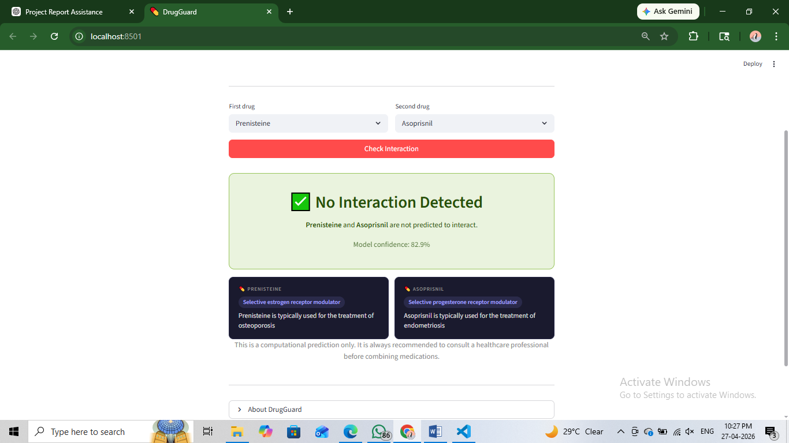

Fig. 4: Prediction output for a non-interacting drug pair
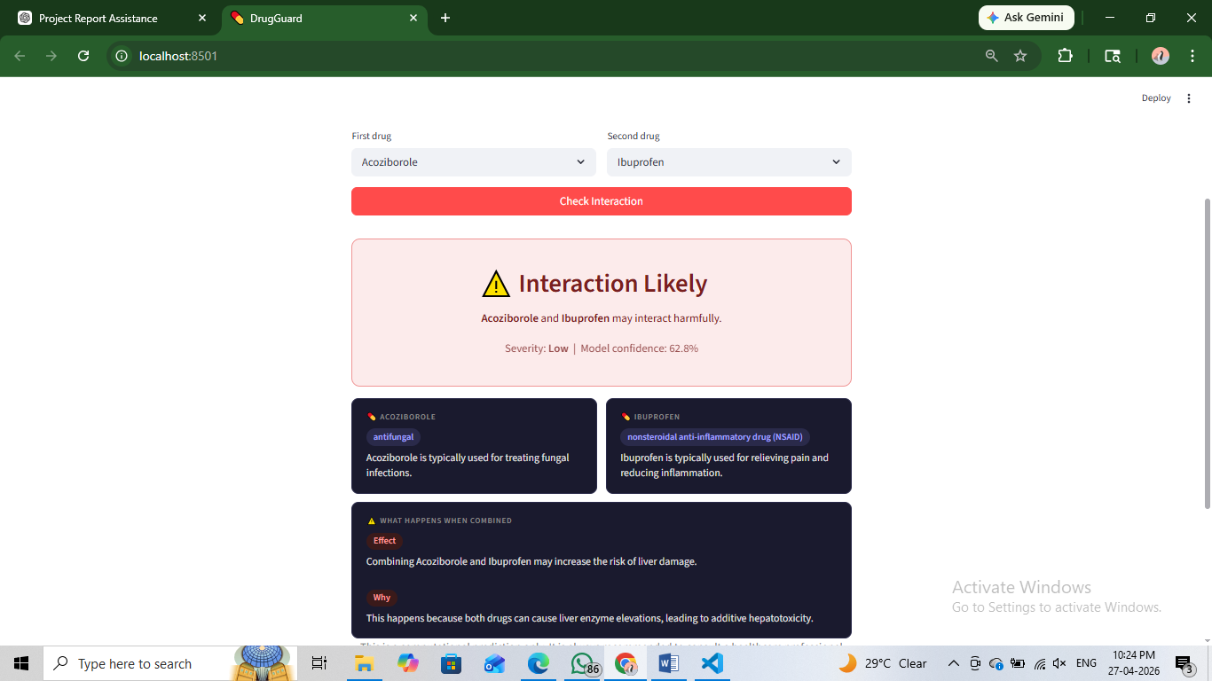

Fig. 5: Prediction output for an interacting drug pair
9. Validation and Justification
In order to determine how dependable the predictions generated by the DrugGuard model are, a group of representative drug pairs will be manually validated using existing pharmacological resources, such as DrugBank and Drugs.com [18]. Both of these resources provide clinically validated data regarding known drug-drug interactions (DDI) and are widely used in both research and the practices of medicine.
In the course of validating a selected drug pair, the relationship between the model’s DDI prediction (DDI or no DDI) was assessed against documented data in these sources. In selected cases, DDI descriptions and severity ratings were compared to validate the consistency of each pair of drug-to-drug DDI predictions made by the DrugGuard model.
The agreement between the DrugGuard model’s DDI predictions and documented DDI relationships was considerably high, thereby confirming the accuracy of the DrugGuard model’s structure-based machine learning approach.
However, both DrugBank and Drugs.com serve primarily as static knowledge retrieval systems; only those DDI relationships that have already been documented can be retrieved from either of these sources. DrugGuard, conversely, is designed to be a predictive system that can generate the probability of a DDI for any drug combination based on molecular structure alone, even for drugs that have not yet received a DDI entry in a traditional pharmacological database.
Consequently, the DrugGuard predictive system builds upon the traditional uses of pharmacological databases by adding a new dynamic capability to predict the probability of DDI interactions between drugs, making it an effective preliminary screening resource.

10. Conclusion
DrugGuard used machine learning techniques that only use chemical structure to predict if two compounds can interact with each other. DrugGuard uses both the SMILES and Morgan fingerprint representations of chemicals, both of which convert the chemical structures into numbers that the XGBoost algorithm can use to classify chemical pairs as 'interacting' or 'not interacting.' This system has the added benefit of having no reliance on additional pharmacological data, such as which proteins a compound interacts with, which metabolic pathways the compounds are part of, or any clinical information about the compounds. The DrugGuard system enhances the generalizability of the model by eliminating the need for the above-mentioned additional pharmacological data.
The experimental testing results showed DrugGuard had an AUC-ROC of 0.78 and successfully distinguished between two types of compounds (interactive vs non-interactive) based only on the chemical structure features, and both of the implemented fingerprints in DrugGuard contributed to the prediction accuracy. Further testing of the effect of the radius of the fingerprint on predictive capability showed that the larger the radius used/radius of 3, which had the highest percentage of correct classifications, the greater the predictive performance of the system. Therefore, as the frequency of similar structures increased in the database used, the more accurately predictions were made using the chemical structure features of compounds.
Another aspect of DrugGuard is its practicability or usability due to its lightweight architecture; that is, the system can use a web-based interface for real-time predictions. To help enhance interpretability and increase user trust in DrugGuard, the system has a combined explanation mechanism that consists of the verified descriptions of the DrugBank database and the fallback from the natural language model that was used. These are critical for systems that will be used in the healthcare industry.
Although not intended to replace existing clinically validated databases, the model will augment existing tools used in early stage screening and discovery of novel drug-drug combinations that aren't well characterized yet, DrugGuard shows significant promise for predicting drug-drug interactions solely based upon structure providing a scalable, efficient, and deployable methodology for facilitating safer medication management.

References
[1] B. Percha and R. B. Altman, “Informatics confronts drug–drug interactions,” Trends in Pharmacological Sciences, 2013.
[2] M. Gil-Sorribes and A. Molina, “Addressing model overcomplexity in drug–drug interaction prediction,” Journal of Cheminformatics, 2026.
[3] A. Sharma et al., “Machine learning approaches for drug interaction prediction,” Indian Journal of Science and Technology, 2020.
[4] Y. Long et al., “Molecular fingerprints are a simple yet effective solution to the drug–drug interaction problem,” ICML Workshop, 2022.
[5] F. Wang et al., “Predicting drug-drug interactions using graph neural networks,” Scientific Reports, 2025.
[6] T. Chen and C. Guestrin, “XGBoost: A scalable tree boosting system,” Proc. ACM SIGKDD, 2016.
[7] B. Zagidullin et al., “Comparative analysis of molecular fingerprints,” Briefings in Bioinformatics, 2021.
[8] R. Zitnik, M. Agrawal, and J. Leskovec, “Modeling polypharmacy side effects with graph convolutional networks,” Bioinformatics, 2018.
[9] S. Liu et al., “Enhancing drug-drug interaction prediction using deep attention neural networks,” IEEE/ACM Transactions, 2022.
[10] DrugBank, “DrugBank Database,” https://www.drugbank.com
[11] A. Gayvert et al., “ChemicalX: A deep learning library for drug pair scoring,” 2020.
[12] J. H. Friedman, “Greedy function approximation: A gradient boosting machine,” Annals of Statistics, 2001.
[13] H. Ryu et al., “DeepDDI: Deep learning-based drug–drug interaction prediction,” Bioinformatics, 2018.
[14] L. Breiman, “Random forests,” Machine Learning, 2001.
[15] R. Kumar et al., “Prediction of drug–drug interactions using data mining techniques,” International Journal of Computer Applications, 2019.
[16] RDKit, “Open-source cheminformatics software,” 2023.
[17] K. Heikamp and J. Bajorath, “Large-scale similarity search profiling of molecular fingerprints,” Journal of Chemical Information and Modeling, 2011.
[18] Drugs.com, “Drug Interactions Checker,” https://www.drugs.com

